Avoices:

GET:<https://natulove-api.onrender.com/avoices> 0.6

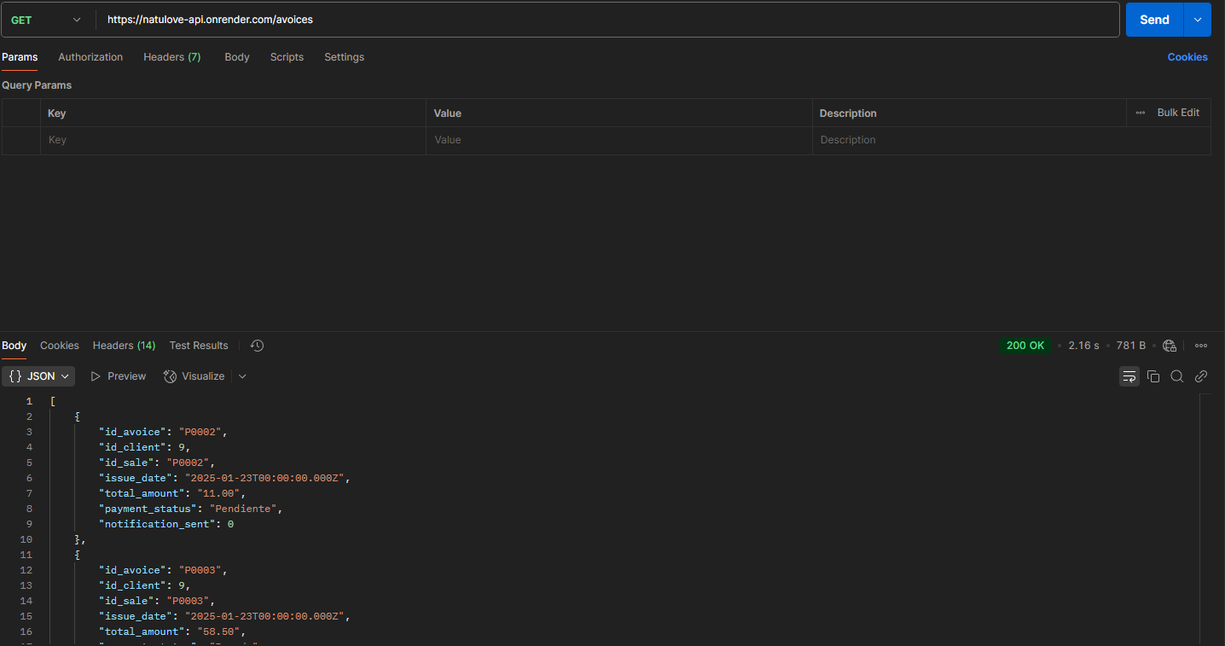

POST:<https://natulove-api.onrender.com/avoices/post> 0.6

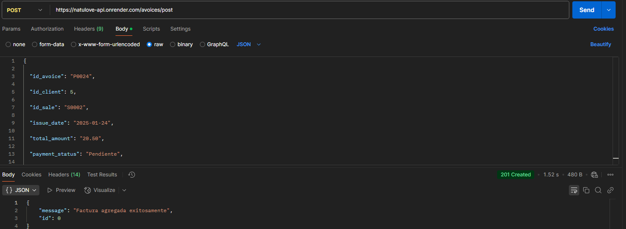



PUT:<https://natulove-api.onrender.com/avoices/put/P0023> 0.6



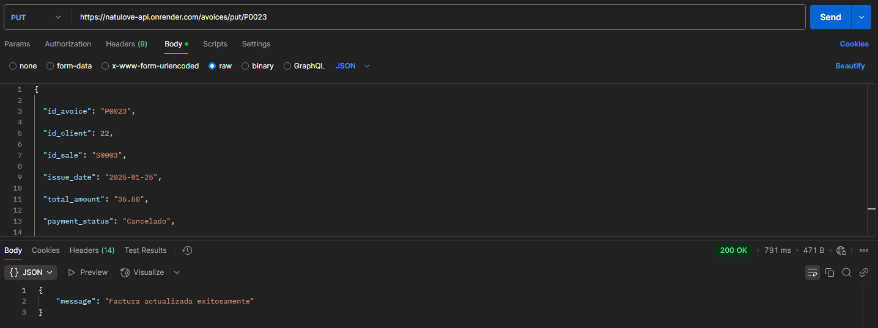



DELETE:<https://natulove-api.onrender.com/avoices/delete/P0023> 0.6

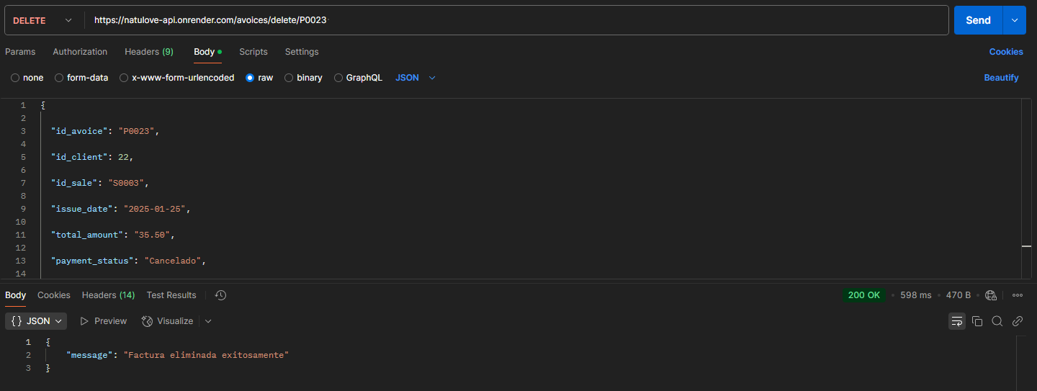



Category:

GET:<https://natulove-api.onrender.com/categories> 0.6

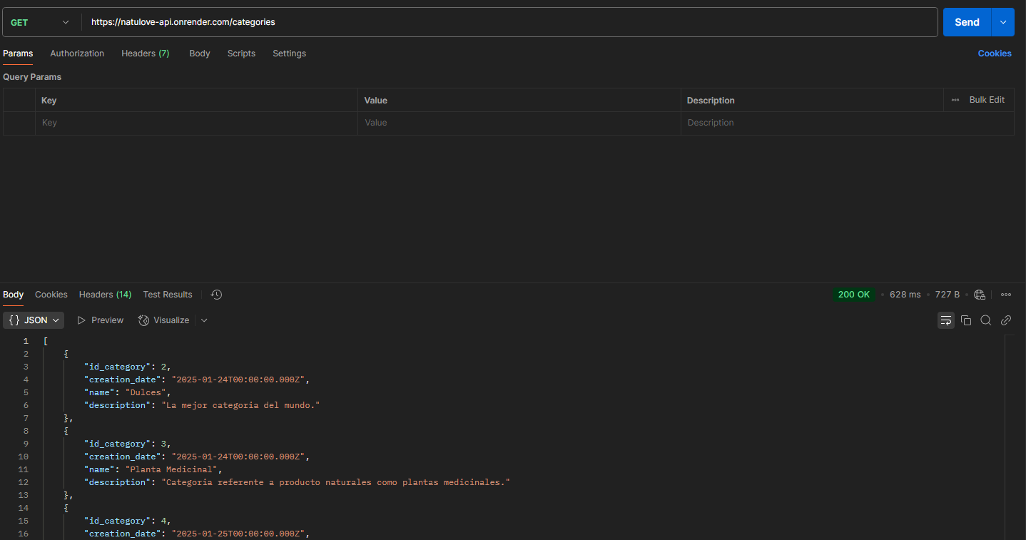

POST:<https://natulove-api.onrender.com/categories/post> 0.6

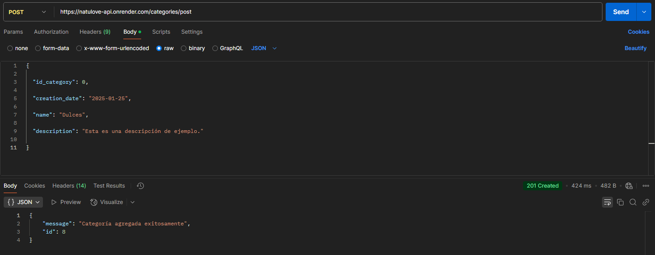



PUT:<https://natulove-api.onrender.com/categories/put/7> 0.6



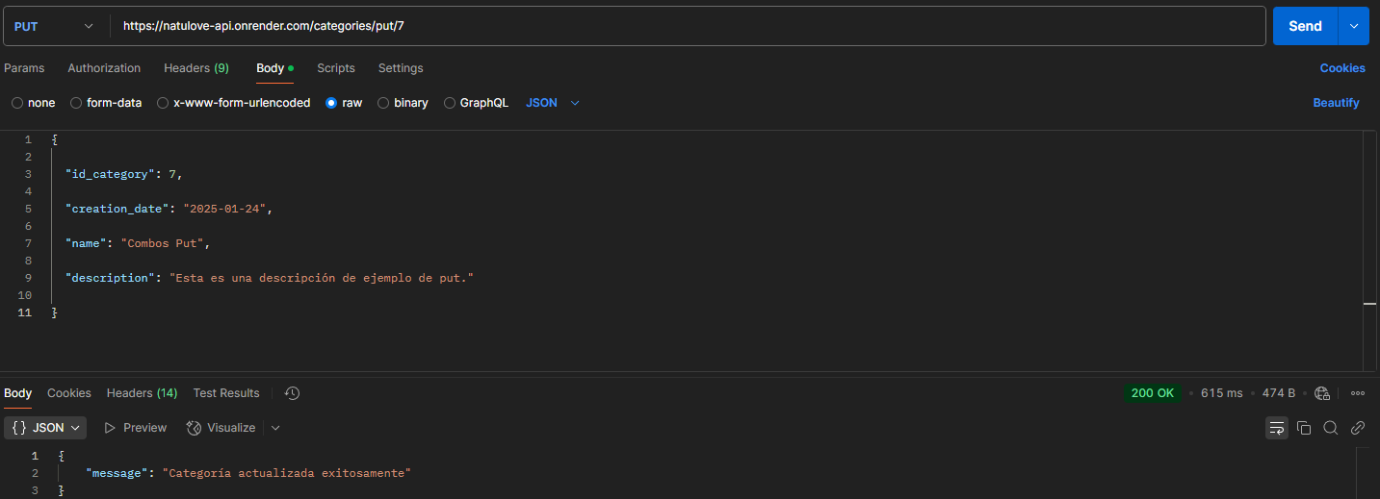



DELETE:<https://natulove-api.onrender.com/categories/delete/7> 0.6



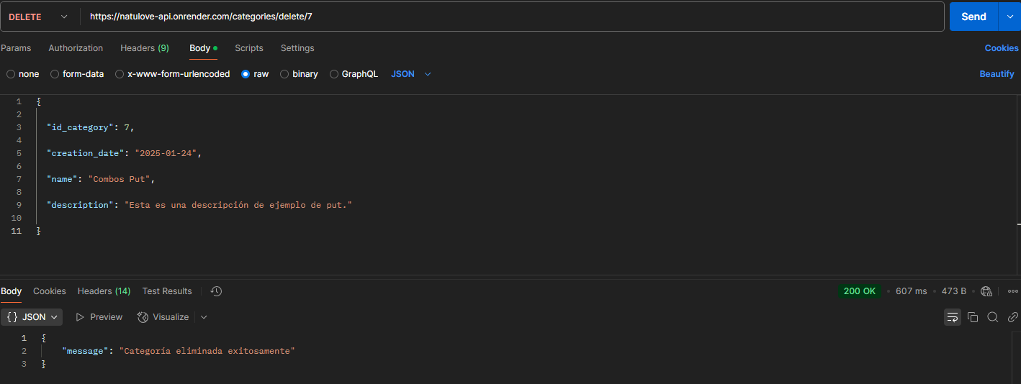



Comentary:

GET:<https://natulove-api.onrender.com/comentaries> 0.6

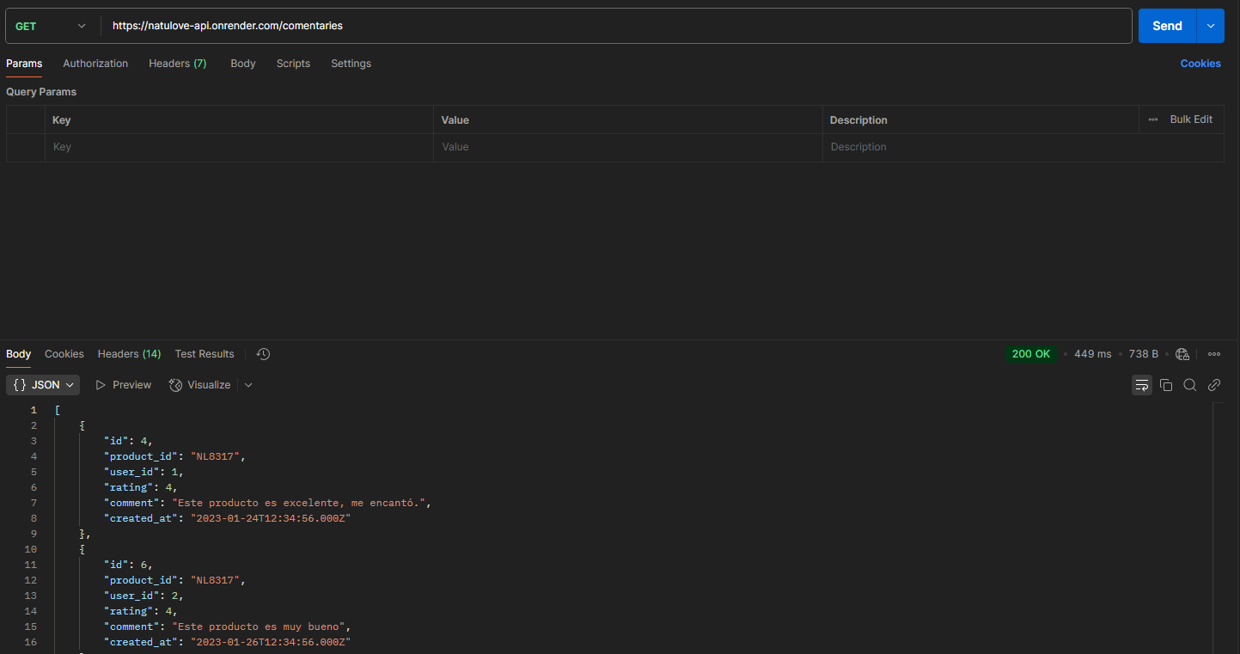

POST:<https://natulove-api.onrender.com/comentaries/post> 0.6

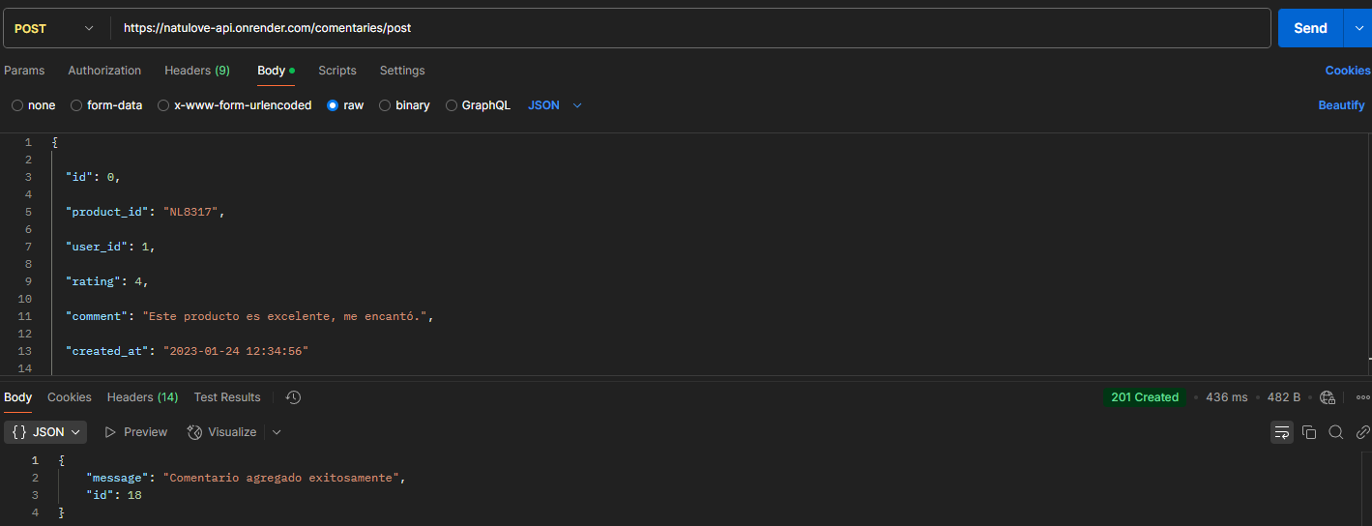



PUT:<https://natulove-api.onrender.com/comentaries/put/12> 0.6



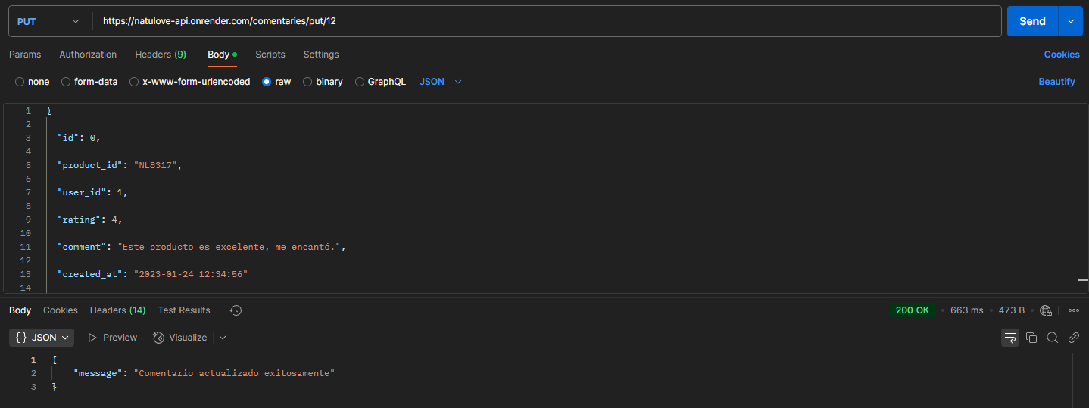



DELETE:<https://natulove-api.onrender.com/comentaries/delete/12> 0.6



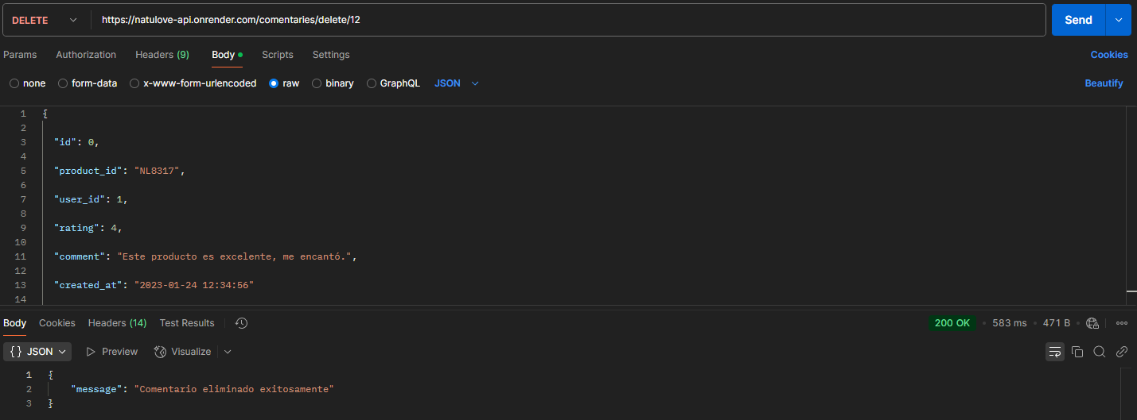



Details_sales:

GET:<https://natulove-api.onrender.com/details_sales> 0.6

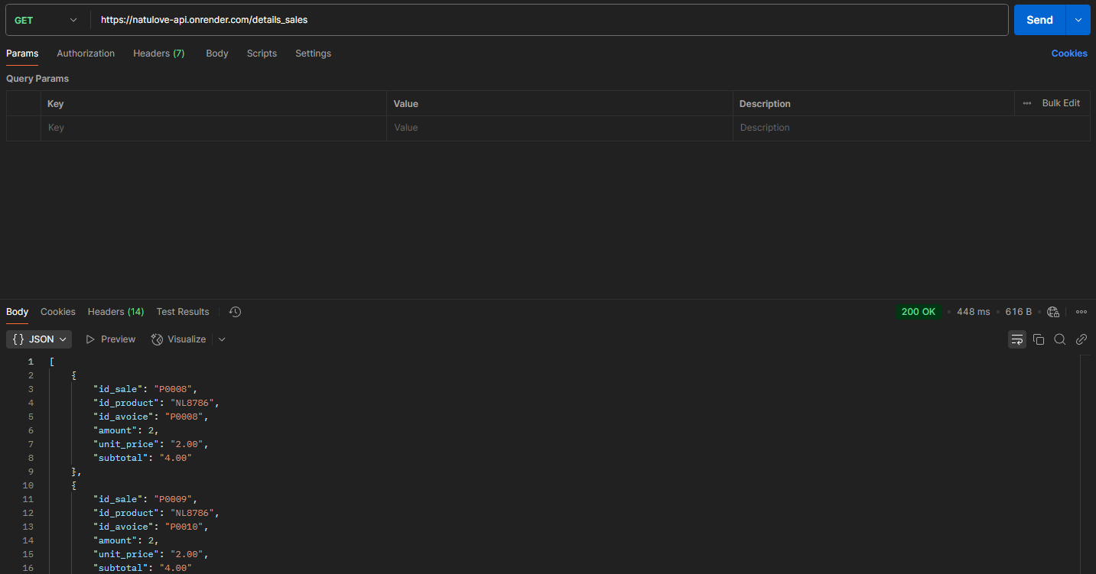

POST:<https://natulove-api.onrender.com/details_sales/post> 0.6

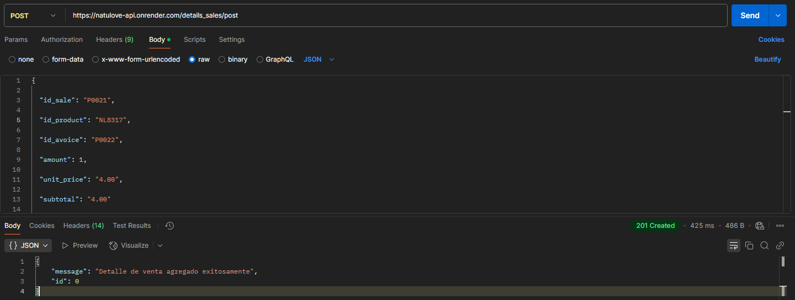

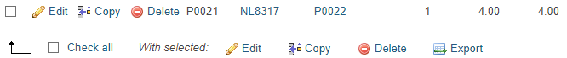

PUT:<https://natulove-api.onrender.com/details_sales/put/P0021/NL8317> 0.6



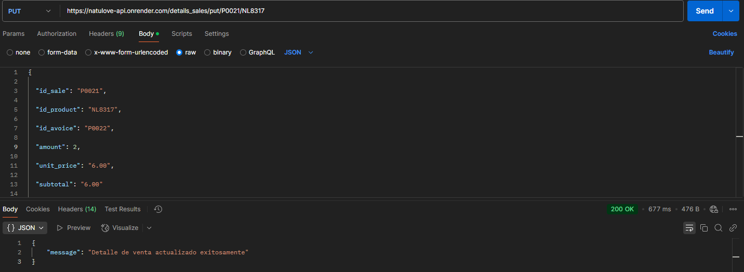



DELETE:<https://natulove-api.onrender.com/details_sales/delete/P0021/NL8317> 0.6



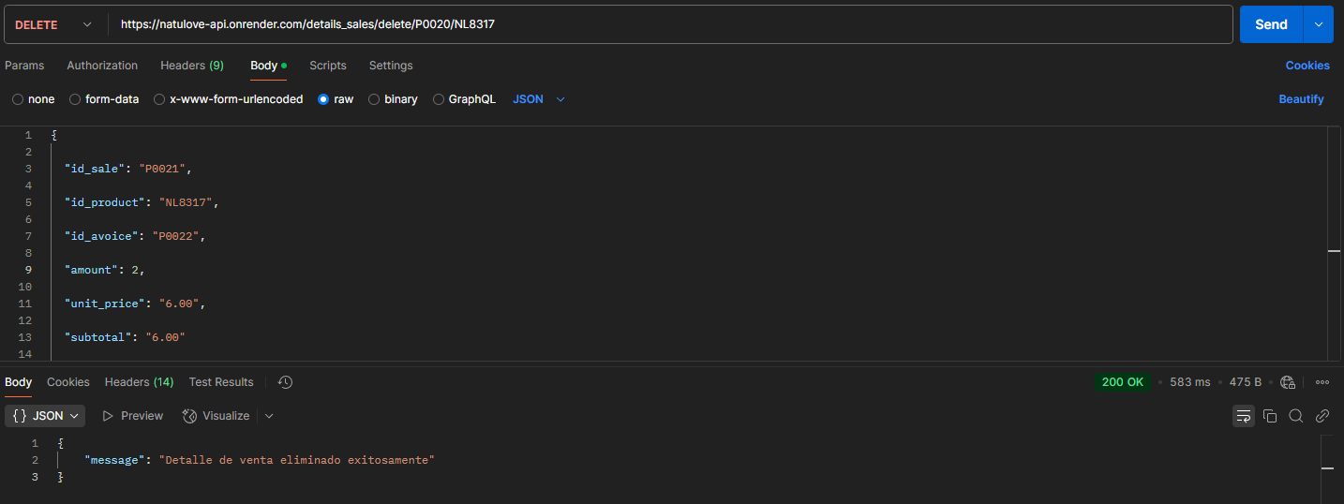



Inventory:

GET:<https://natulove-api.onrender.com/inventory> 0.6

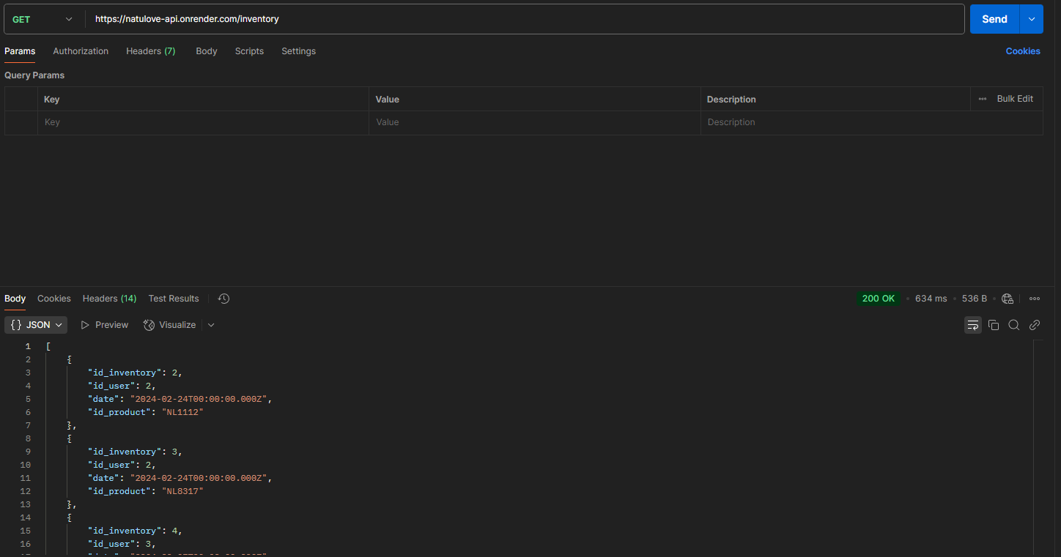

POST:<https://natulove-api.onrender.com/inventory/post> 0.6

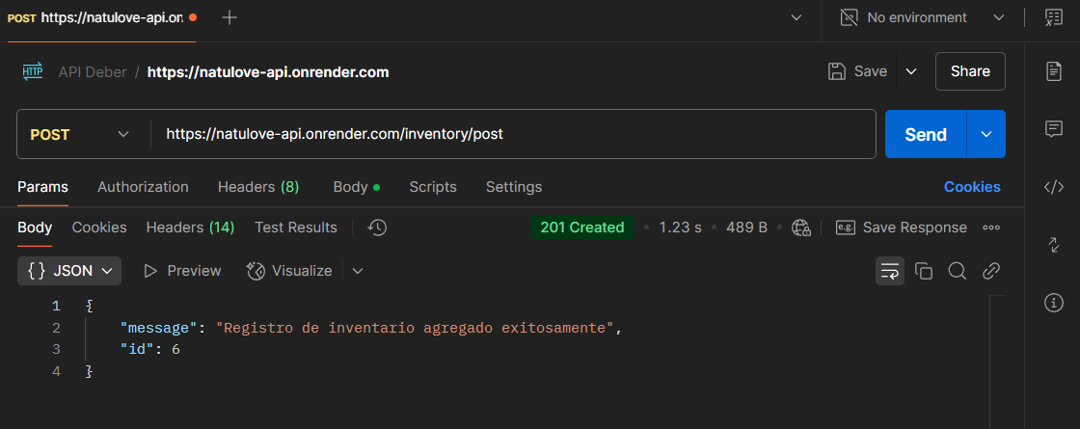

PUT:<https://natulove-api.onrender.com/inventory/put/5> 0.6

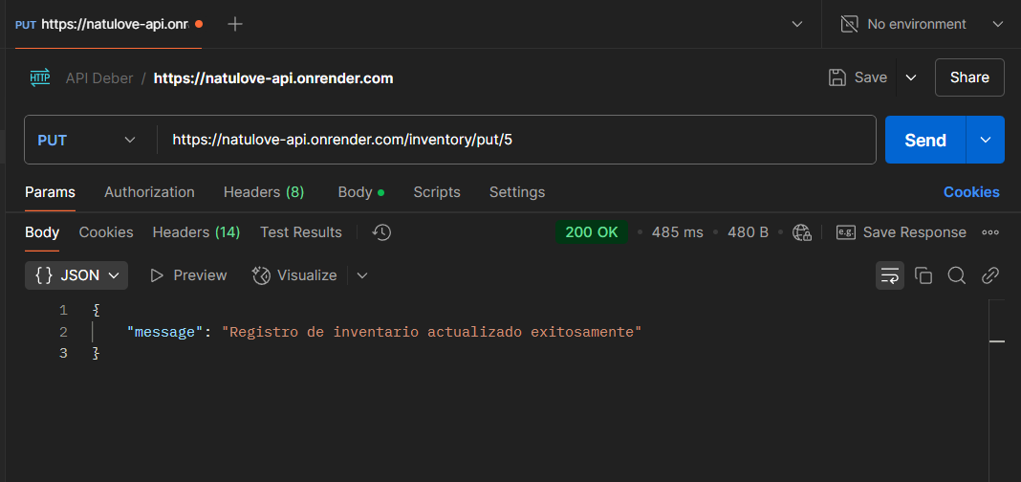

DELETE:<https://natulove-api.onrender.com/inventory/delete/5> 0.6

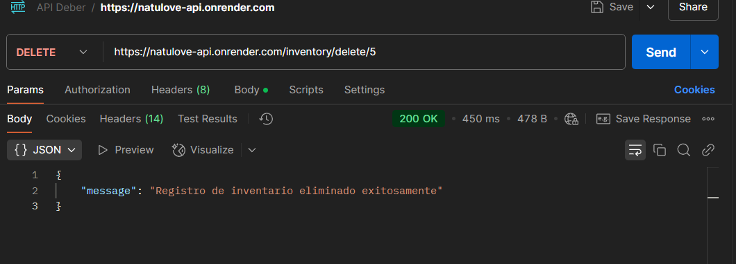

Payments:

GET:<https://natulove-api.onrender.com/payments> 0.6

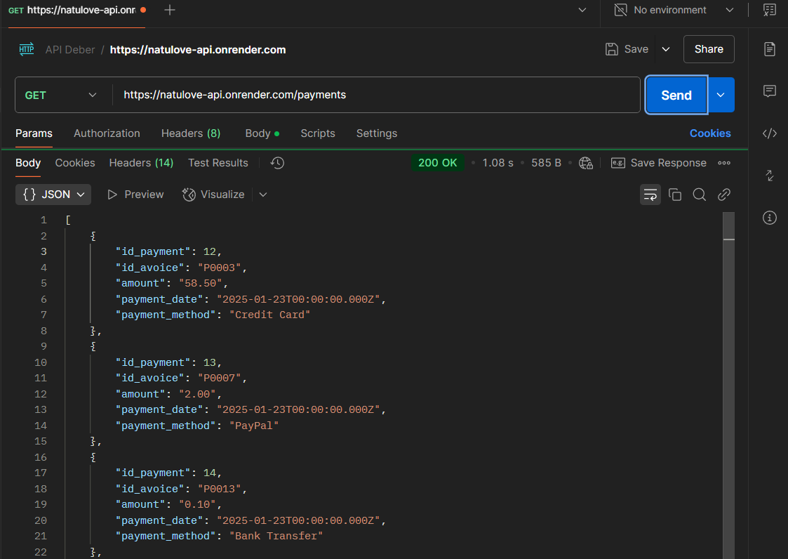

POST:<https://natulove-api.onrender.com/payments/post> 0.6

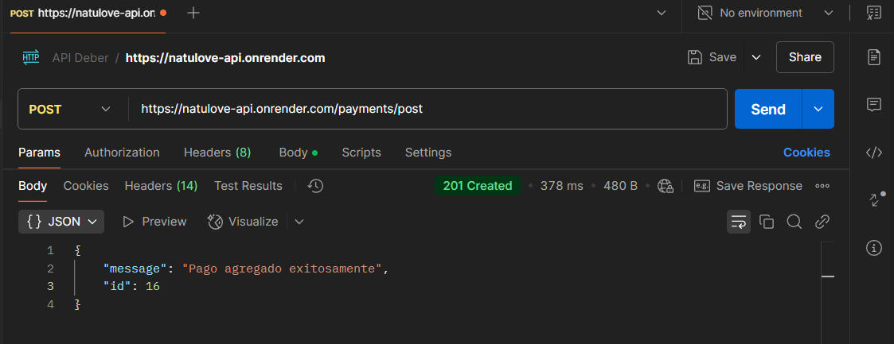

PUT:<https://natulove-api.onrender.com/payments/put/15> 0.6

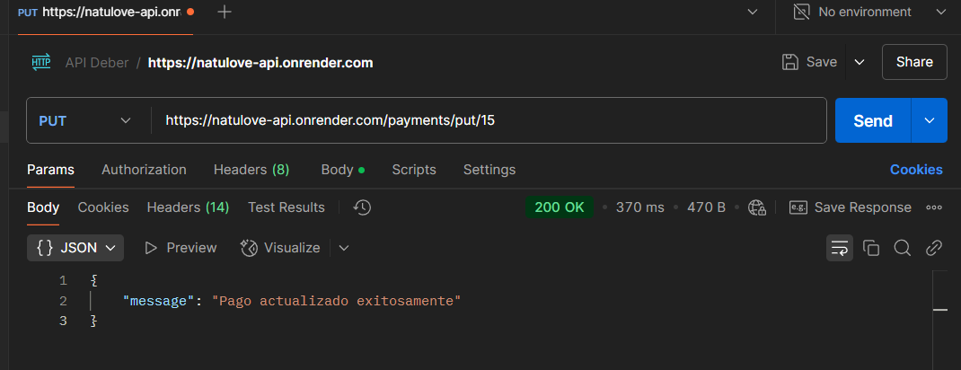

DELETE:<https://natulove-api.onrender.com/payments/delete/15> 0.6

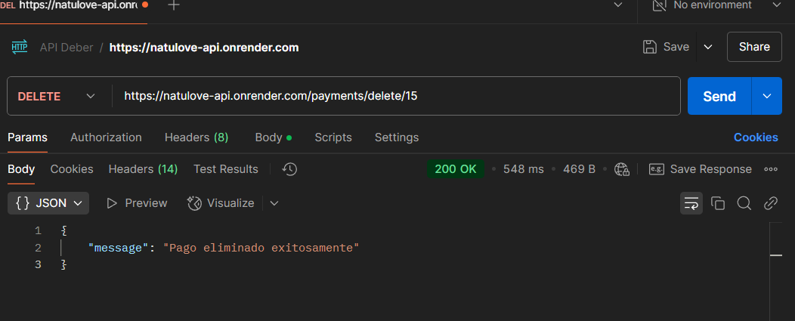

Products:

GET:<https://natulove-api.onrender.com/products> 0.1

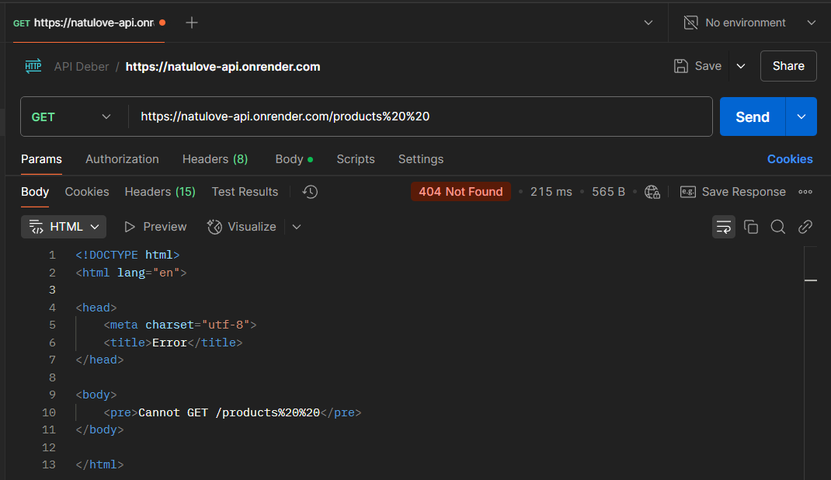

POST: [https://natulove-api.onrender.com/ products/post](https://natulove-api.onrender.com/%20products/post) 0.1

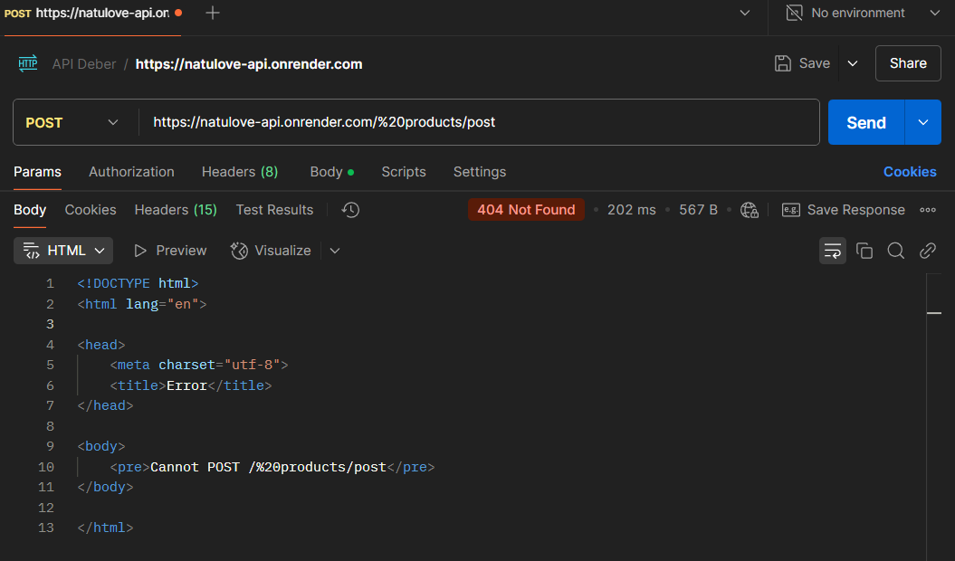

PUT: [https://natulove-api.onrender.com/ products/put/NL9075](https://natulove-api.onrender.com/%20products/put/NL9075%20%20)  0.1

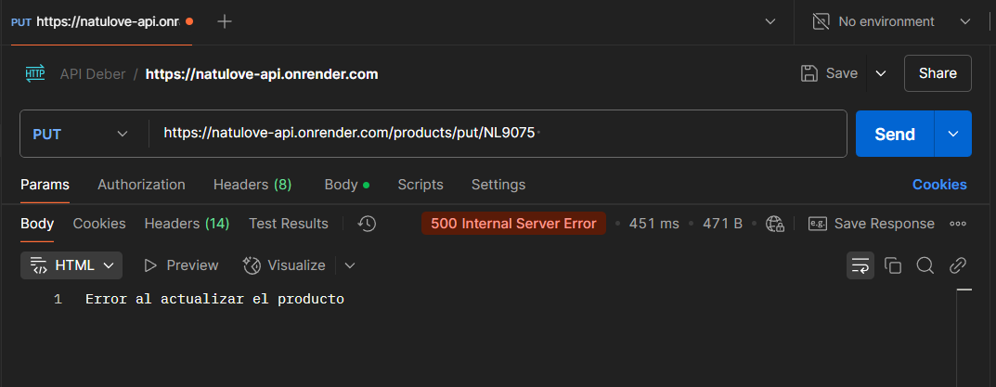

DELETE: [https://natulove-api.onrender.com/ products/delete/NL9075](https://natulove-api.onrender.com/%20products/delete/NL9075%20%20)  0.6

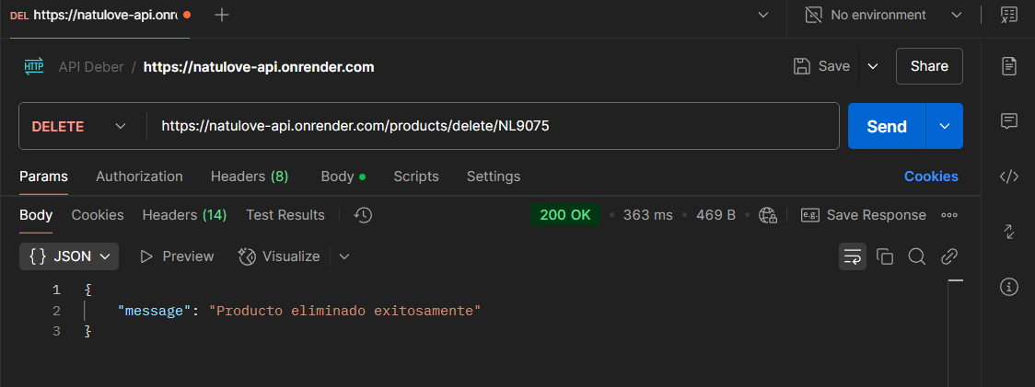

Role:

GET: [https://natulove-api.onrender.com/roles](https://natulove-api.onrender.com/roles%20%20%20)  0.6

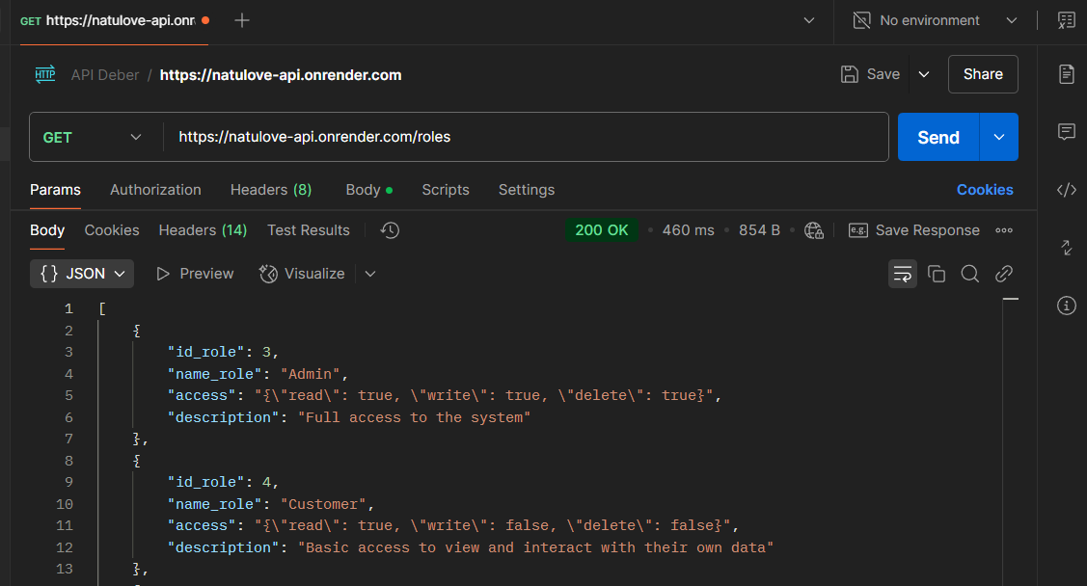

POST:<https://natulove-api.onrender.com/roles/post> 0.1

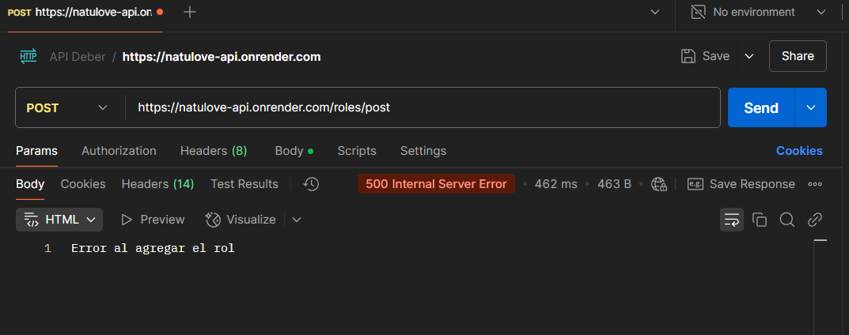

PUT:<https://natulove-api.onrender.com/roles/put/12> 0.1

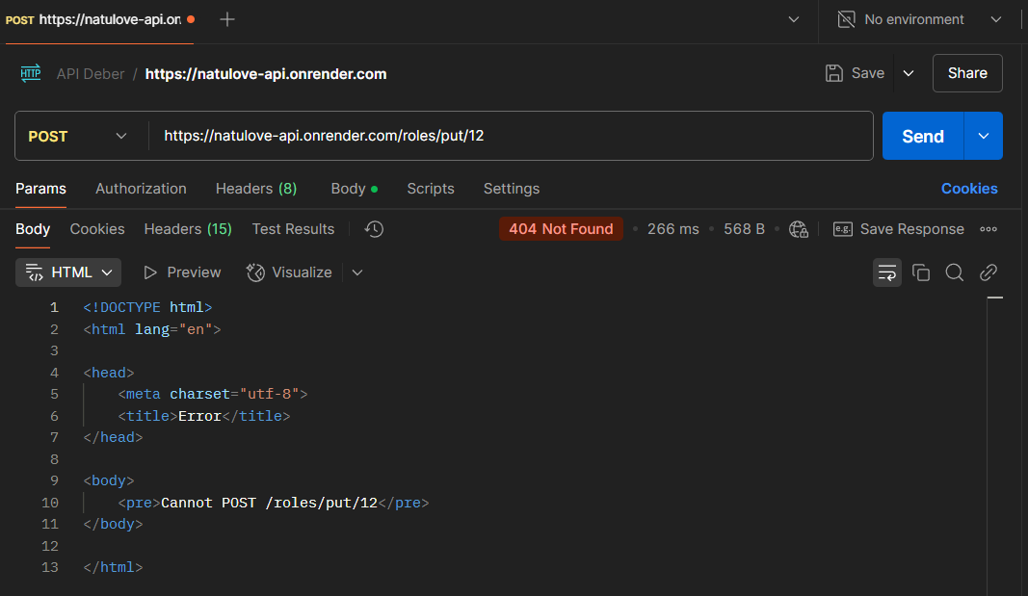

DELETE:<https://natulove-api.onrender.com/roles/delete/12> 0.6

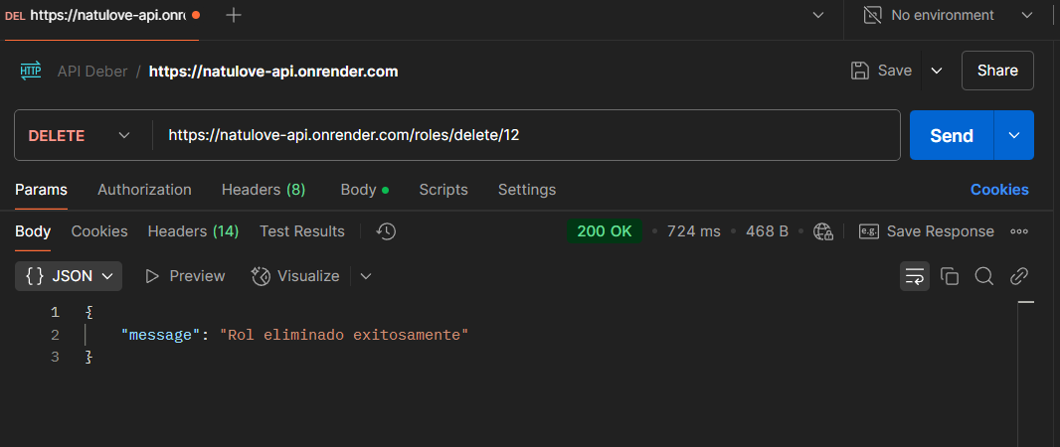

Sales:

GET:<https://natulove-api.onrender.com/sales> 0.6

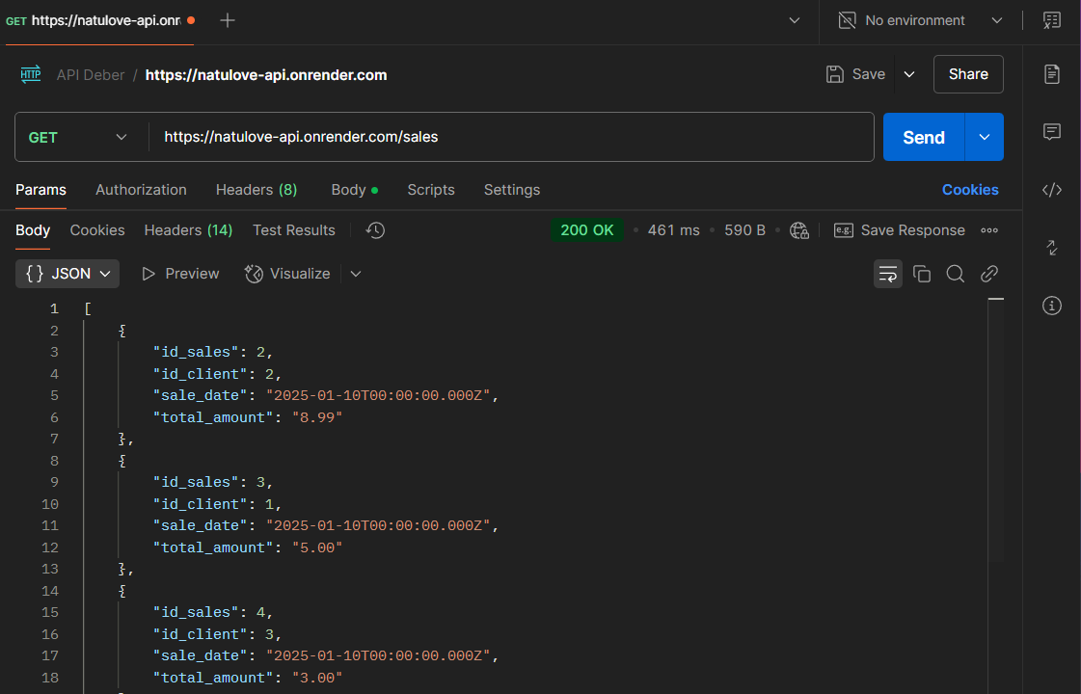

POST:<https://natulove-api.onrender.com/sales/post> 0.6

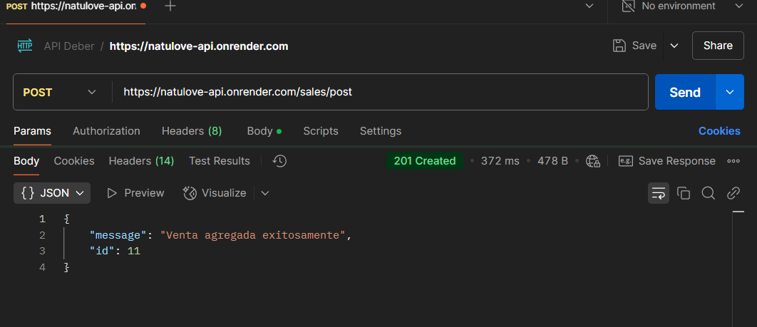

PUT:<https://natulove-api.onrender.com/sales/put/10> 0.6

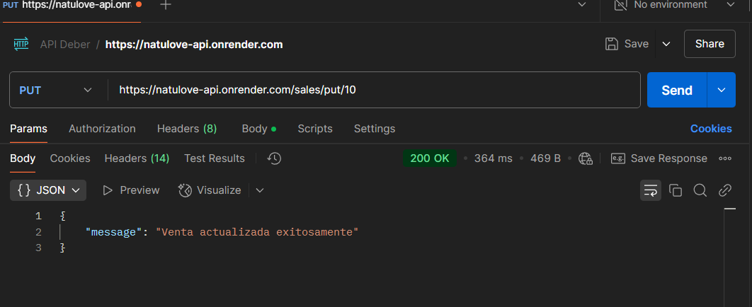

DELETE:<https://natulove-api.onrender.com/sales/delete/10> 0.6

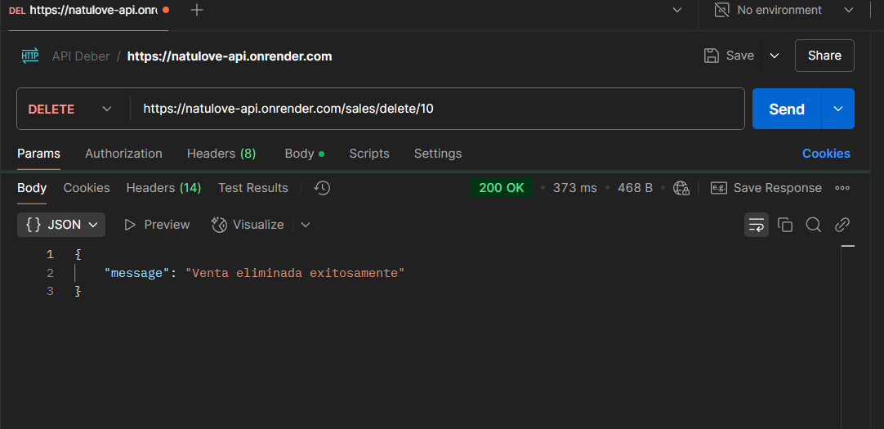

Users:

GET:<https://natulove-api.onrender.com/users> 0.6

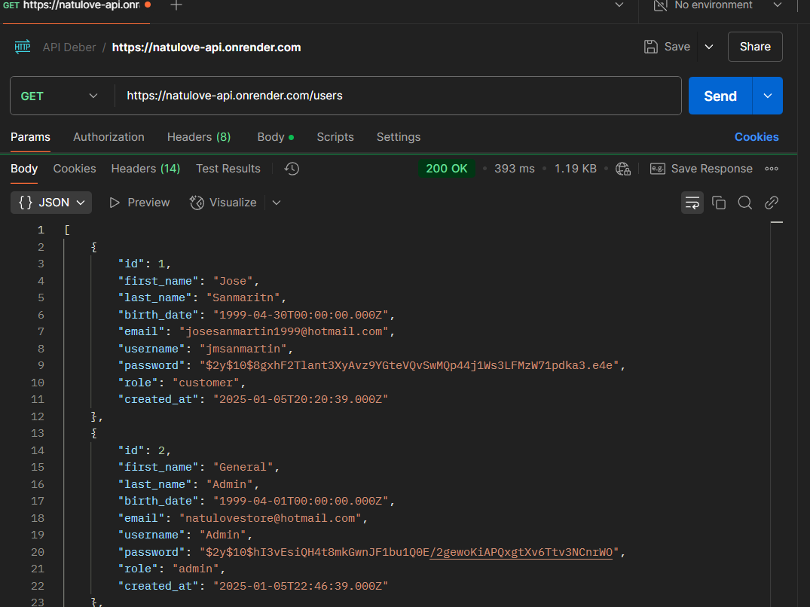

POST:<https://natulove-api.onrender.com/users/post> 0.1

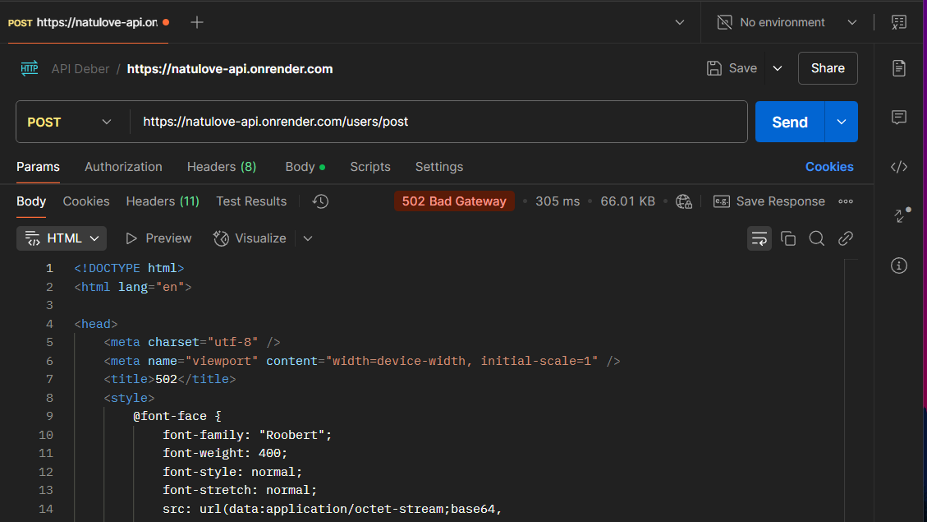

PUT:<https://natulove-api.onrender.com/users/put/22> 0.1

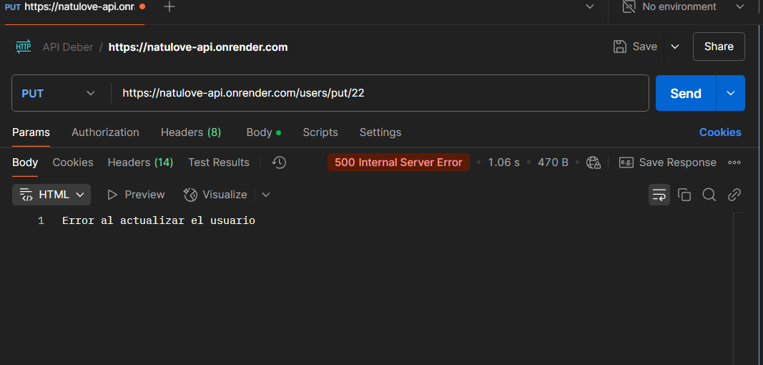

DELETE:<https://natulove-api.onrender.com/users/delete/22> 0.6

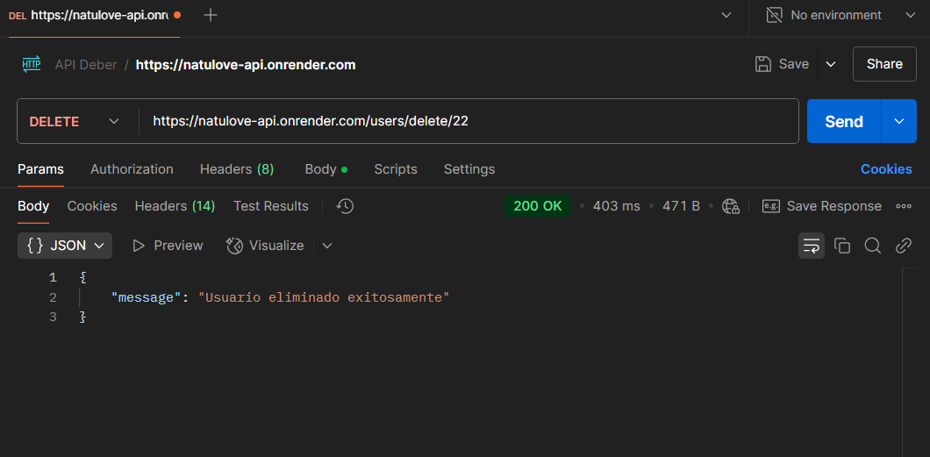

**Business rules**

View catalog

[https://natulove-api.onrender.com/products/catalog](https://natulove-api.onrender.com/products/catalogHYPERLINK%20%22https://natulove-api.onrender.com/products/catalog?category=Dulce)[?category=Dulce](https://natulove-api.onrender.com/products/catalog?category=Dulce) 0.1

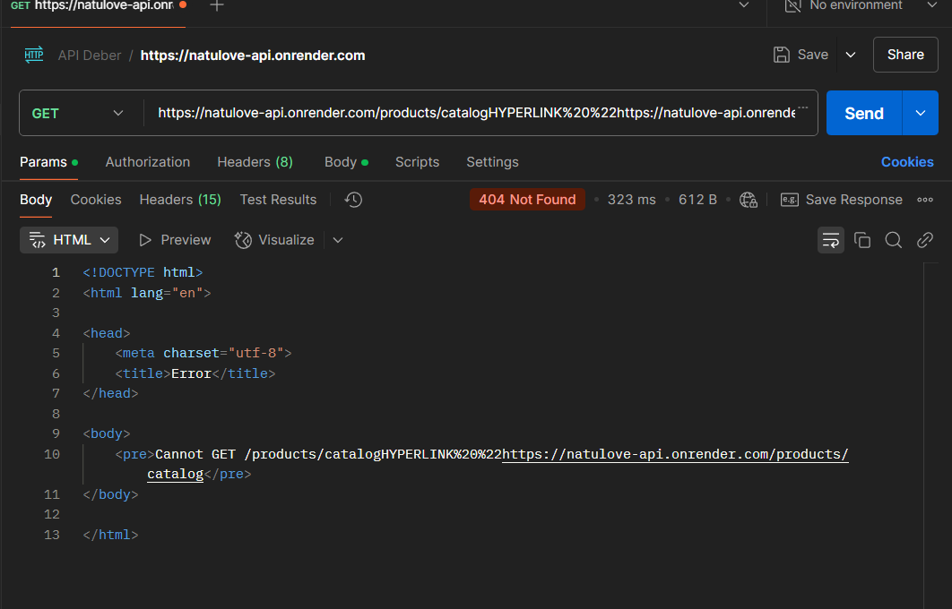

Sum of sales

<https://natulove-api.onrender.com/sales/2025/03> 0.6

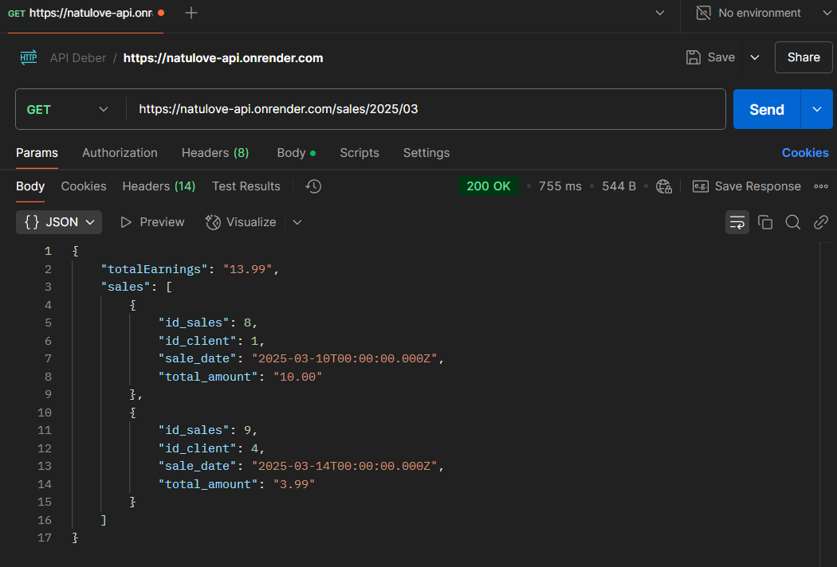

Products sum

<https://natulove-api.onrender.com/details_sales/total/P0020> 0.6

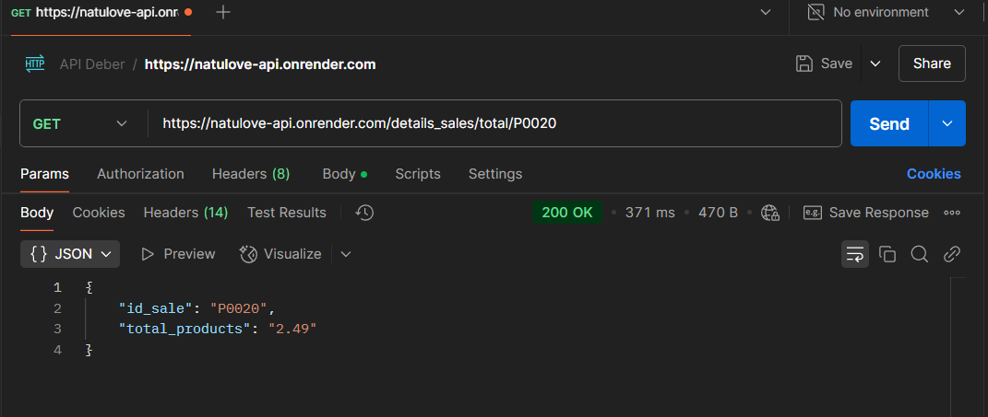

Classify comments

<https://natulove-api.onrender.com/comentaries/rating/4> 0.6

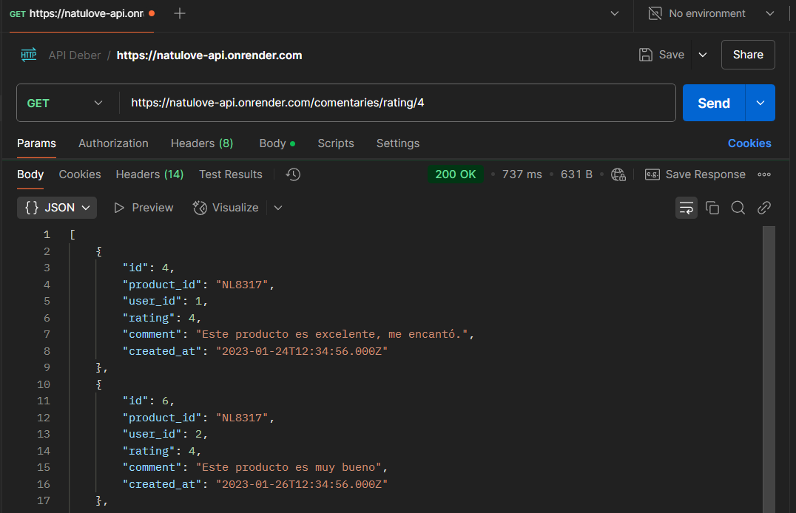

Calculate age

<https://natulove-api.onrender.com/users/age/25> 0.6

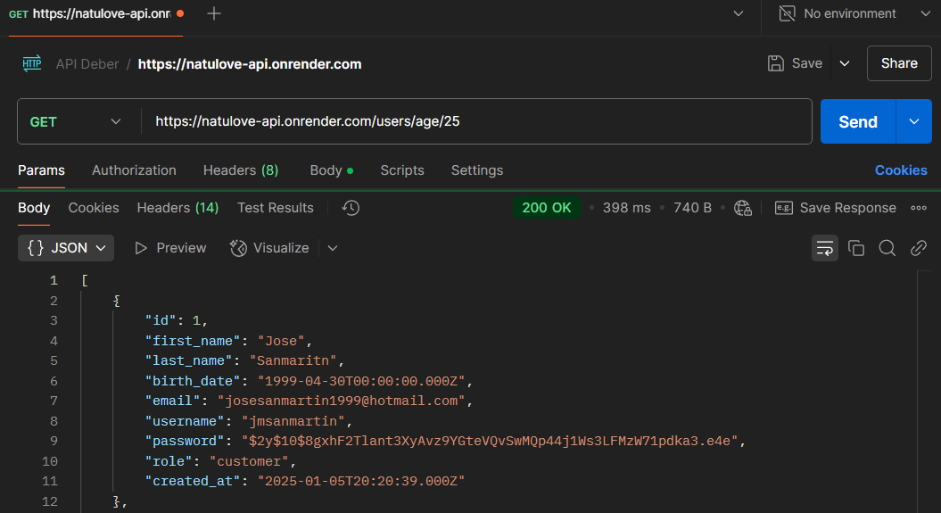

Classify user

<https://natulove-api.onrender.com/users/role/admin> 0.6

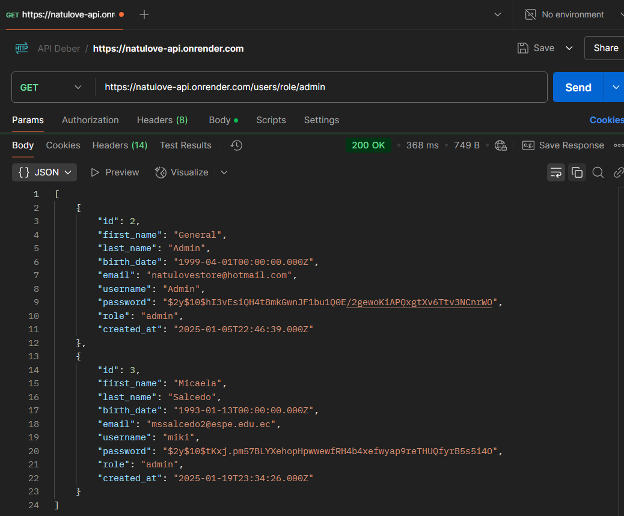

Calculate IVA

<https://natulove-api.onrender.com/sales/with-tax> 0.6

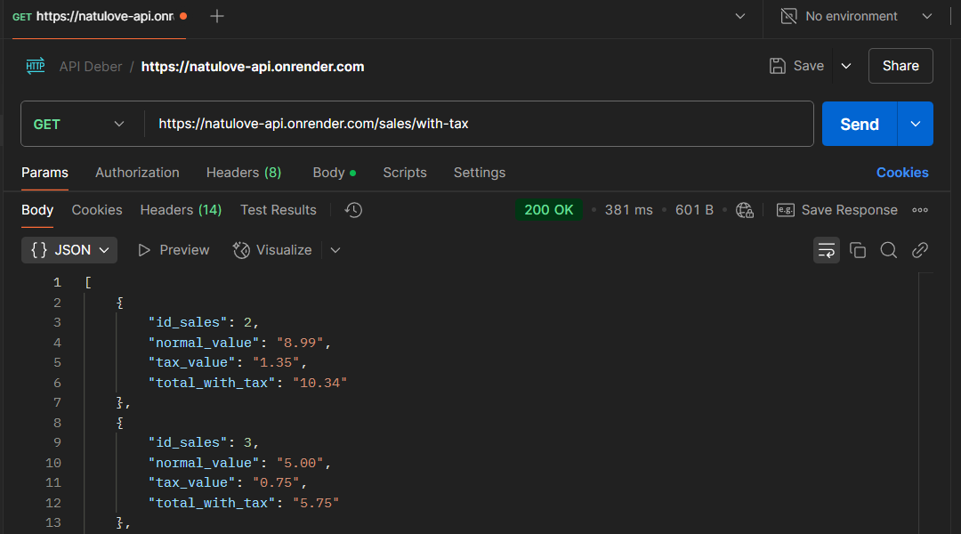

Export to PDF

<https://natulove-api.onrender.com/export/users> 0.6

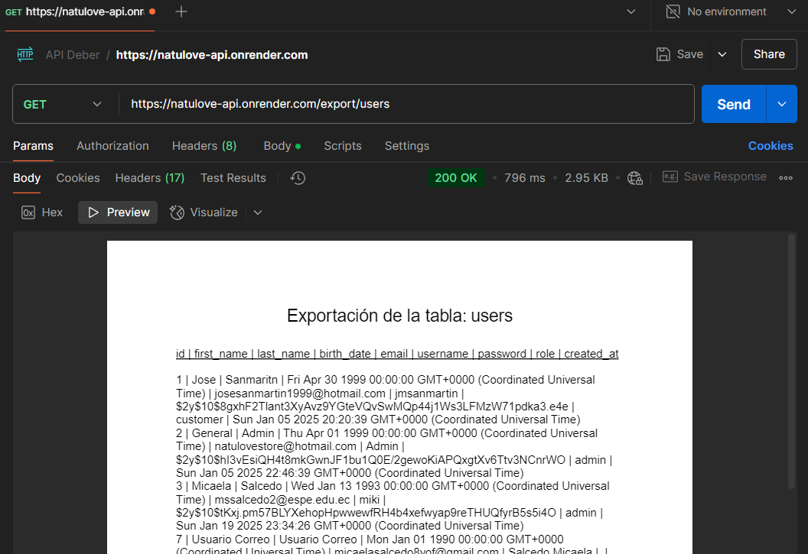

Classify state

<https://natulove-api.onrender.com/avoices/status/Pendiente> 0.6

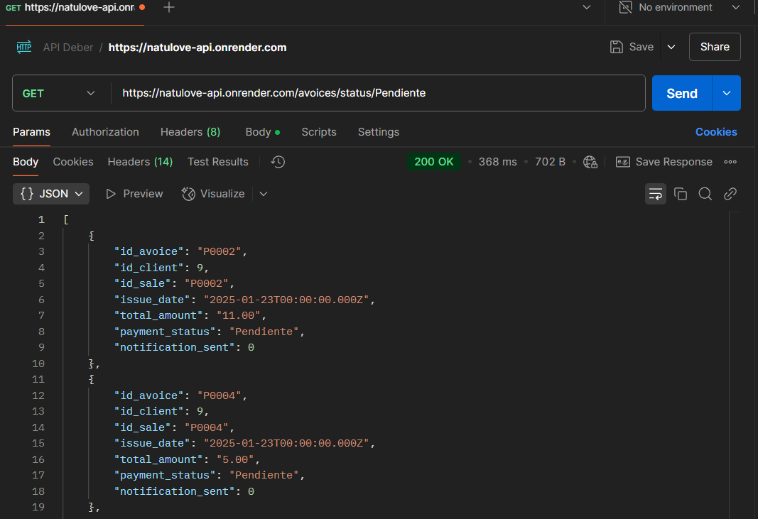

Classify inventory

<https://natulove-api.onrender.com/inventory/user/2> 0.6

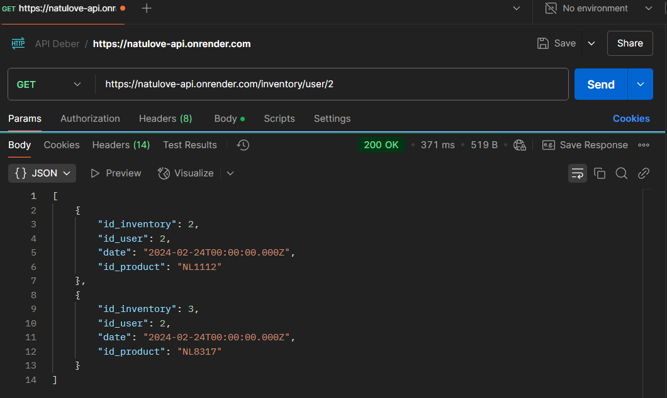

7. Clean code (MVC)

